**😊 Amazon Comprehend**

Amazon Comprehend is a fully managed natural language processing (NLP) service by AWS that helps you uncover insights and relationships in text using machine learning. It's designed to process large amounts of unstructured data and provides capabilities to extract key information from the text, such as the overall sentiment, entities, key phrases, and more. You don’t need prior expertise in machine learning to use it, and it automatically scales based on the volume of text.

**Key Features:**

1. **Sentiment Analysis**:
   * Identifies the sentiment (positive, negative, neutral, or mixed) within the text. It is commonly used in applications like customer feedback analysis to understand user opinions.
2. **Entity Recognition**:
   * Detects and categorizes entities such as people, locations, organizations, dates, and quantities within the text.
3. **Key Phrase Extraction**:
   * Extracts important phrases from a document, helping to summarize the core information.
4. **Language Detection**:
   * Automatically detects the language of the input text. This is useful in multi-language environments to route text to the appropriate processing service.
5. **Text Classification**:
   * Classifies documents into predefined or custom categories. For example, it can categorize support tickets by type, product, or urgency.
6. **Custom Entity Recognition**:
   * You can train the service to recognize custom entities specific to your use case (e.g., product codes, industry terms).
7. **Topic Modeling**:
   * Helps you analyze a collection of documents by grouping them into different topics or themes based on the contents of the text.

**How It Works:**

Amazon Comprehend uses machine learning models trained on a large corpus of text data. You can either use the pre-trained models or train your own custom models using your data. Once the text is submitted to the service, Comprehend processes the information and returns insights such as detected entities, sentiments, and key phrases.

**Common Use Cases:**

* **Customer Support**: Analyze support tickets to detect common complaints and themes.
* **Sentiment Analysis**: Gauge customer sentiment from social media, reviews, or feedback forms.
* **Text Classification**: Automatically sort emails or documents into specific categories.
* **Document Search and Organization**: Enhance search functionality by tagging documents with topics, keywords, and entities.
* **Media Monitoring**: Analyze large-scale text sources such as news articles or social media posts for relevant mentions or sentiment trends.

**Integration with Other AWS Services:**

Amazon Comprehend can be integrated with other AWS services, such as:

* **Amazon S3**: Store text data in S3 and use Comprehend to process the files.
* **AWS Lambda**: Trigger text analysis based on events.
* **Amazon Kinesis**: Stream text data for real-time analysis.

Overall, Amazon Comprehend is a powerful tool for businesses looking to derive actionable insights from large volumes of text, allowing them to improve customer service, monitor brand reputation, and organize information more effectively.

**To begin with this Lab:**

1. In your AWS Console, search for Amazon Comprehend and choose the service accordingly.

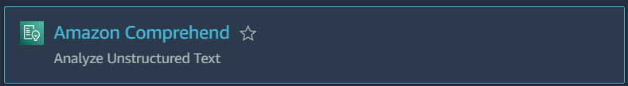

1. Below you can see the dashboard for Amazon Comprehend. Click on launch.

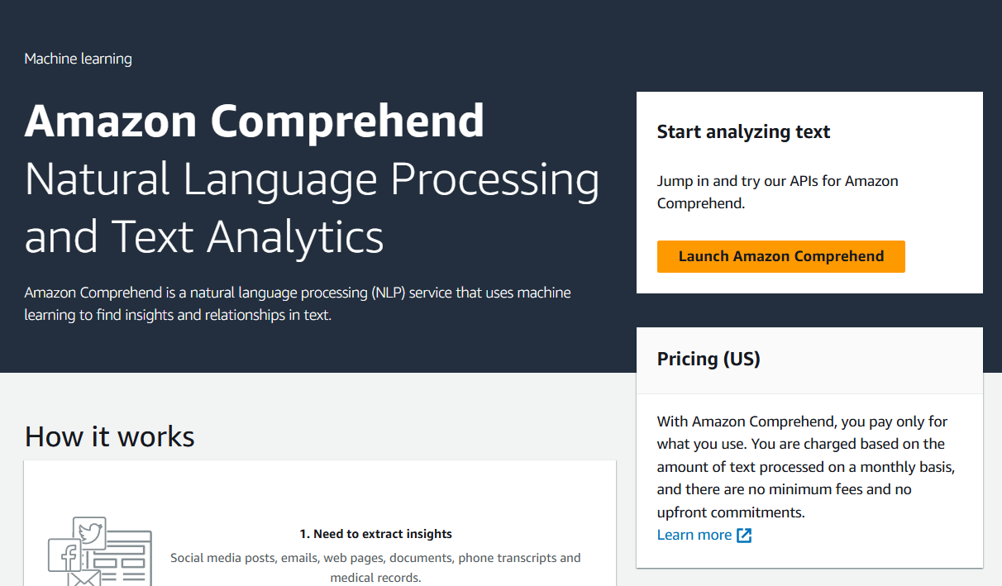

1. This tool does the real time analysis of our text. Basically, what you can do is generate a random input text and then paste it here and click on Analyze.

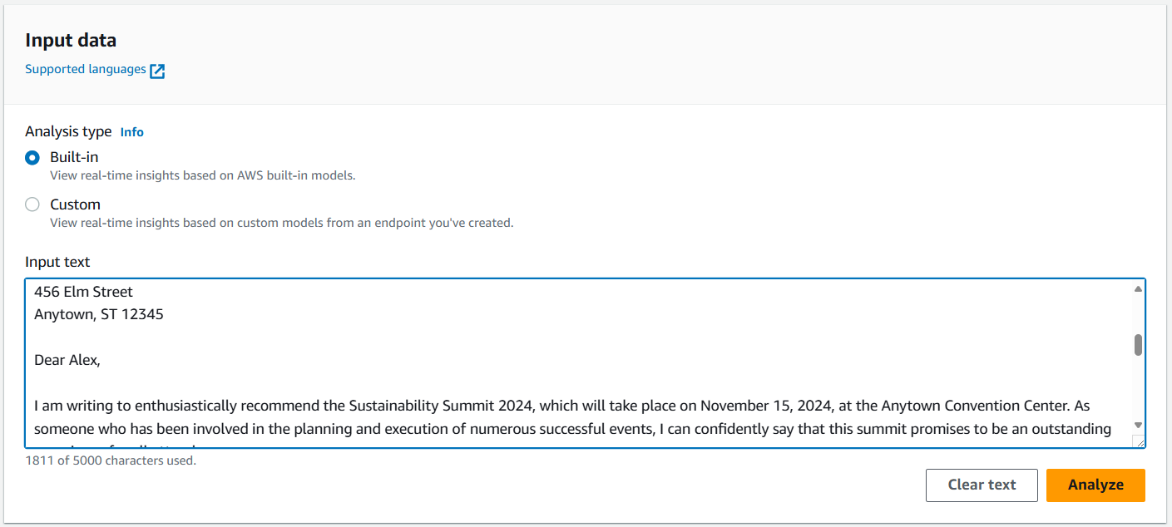

1. Once it has analyzed the text it will give you the entities, key phrases, language, PII, Sentiment, Targeted sentiment and Syntax for your given text.

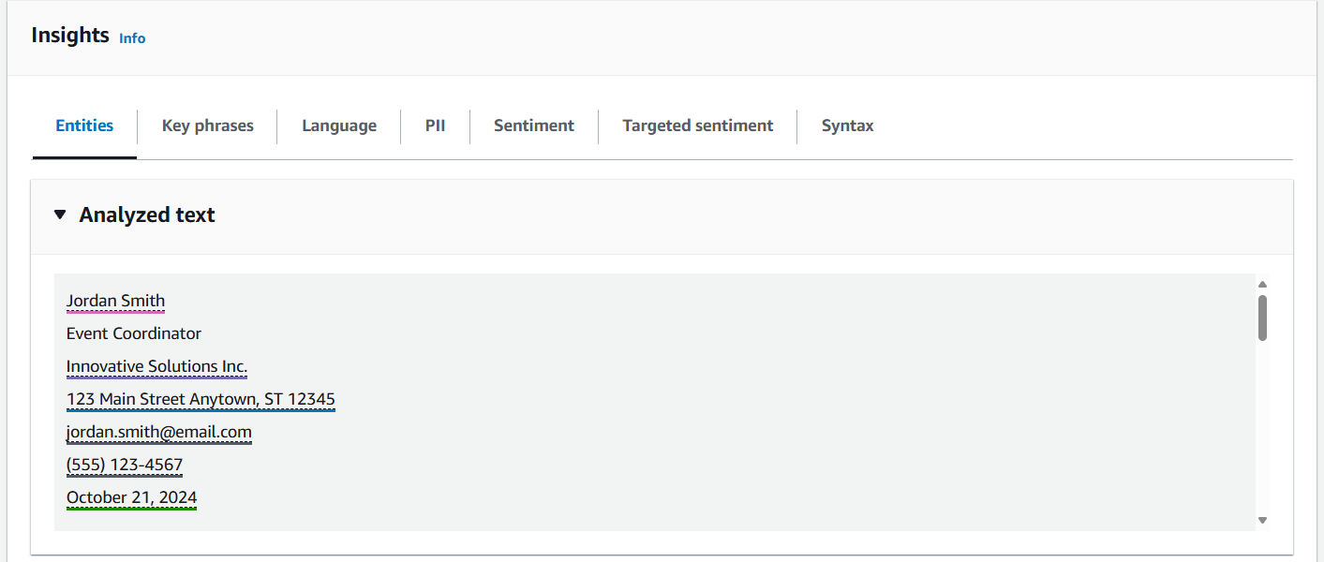

1. Below is the result for entities. Similarly, you can find different results for different options it is providing to you.

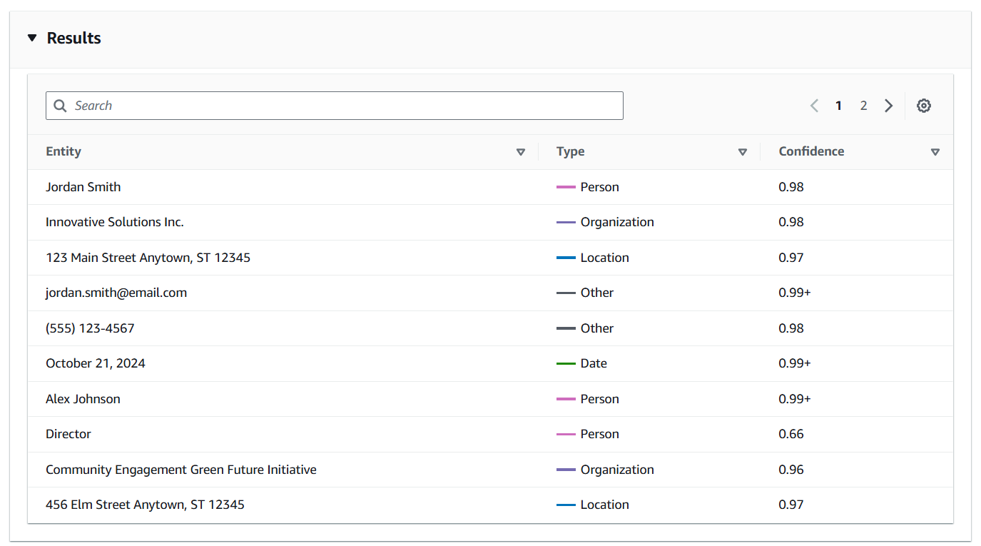

1. So, this is the result for Key phrases.

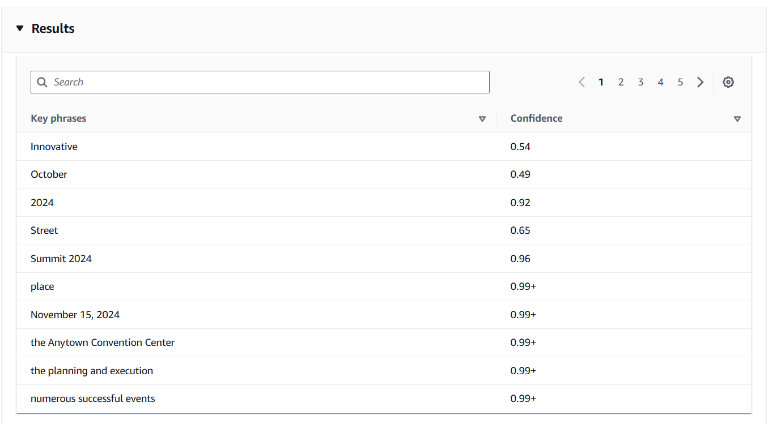

1. For language it is confident that this language is 99% English.

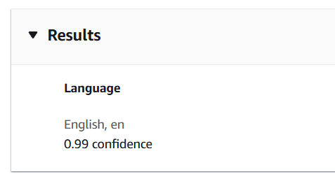

1. In PII you have two options offsets and Labels.

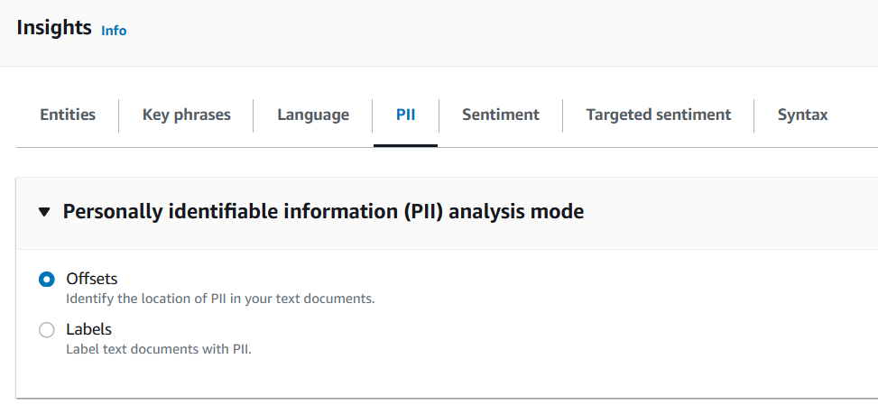

1. In the sentiments, you can see that it 86% neutral and 13% positive. Similarly, you can view all the results.

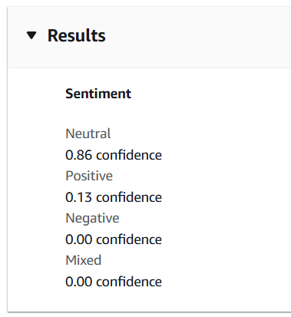

1. Then we used another text and analyzed it, here we can see that it has 98% negative sentiments.

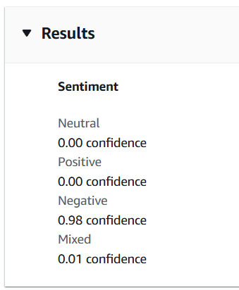

1. Now there is another service Amazon Comprehend Medical. Here you can analyze medical text. Click on launch.

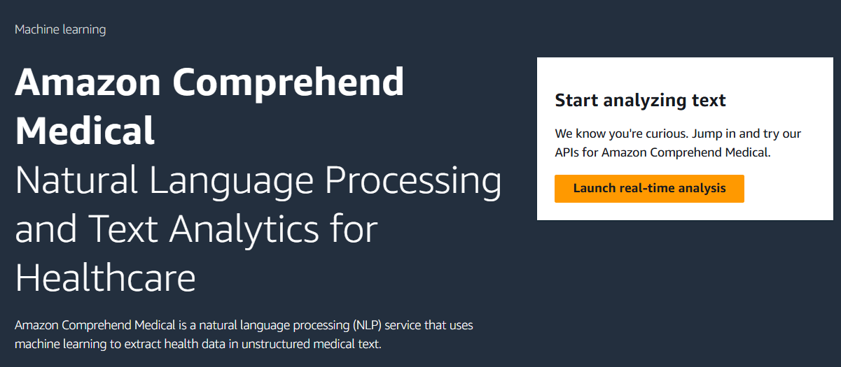

1. In this we have a predefined text which is already analyzed.

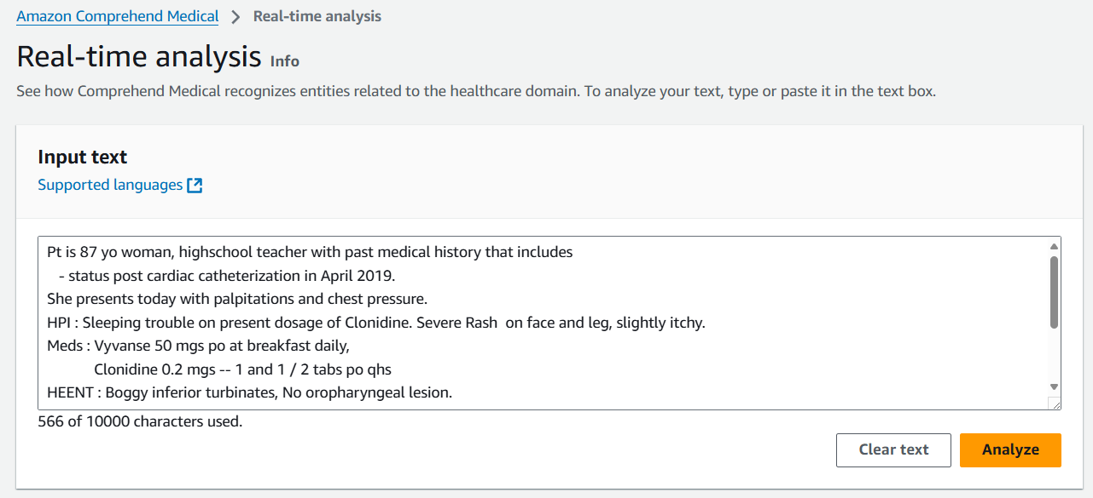

1. And in the entities, you have a visual type of representation of your text. You can view all the thigs you want.

